Create a highly detailed and realistic image showing the neck of a person with really exteremely dark brown skin. The neck should display a typical ringworm infection, characterized by a clearly visible, circular red rash with a slightly raised, scaly border and healthy-looking skin in the center. The emphasis remains on the neck and the detailed depiction of the skin condition



A realistic and detailed image depicting the neck of a person with dark brown skin. The neck shows a ringworm infection with a distinct circular red rash, featuring a slightly elevated, scaly border and a healthier-looking interior. The focus is on the neck and its accurate depiction of ringworm.

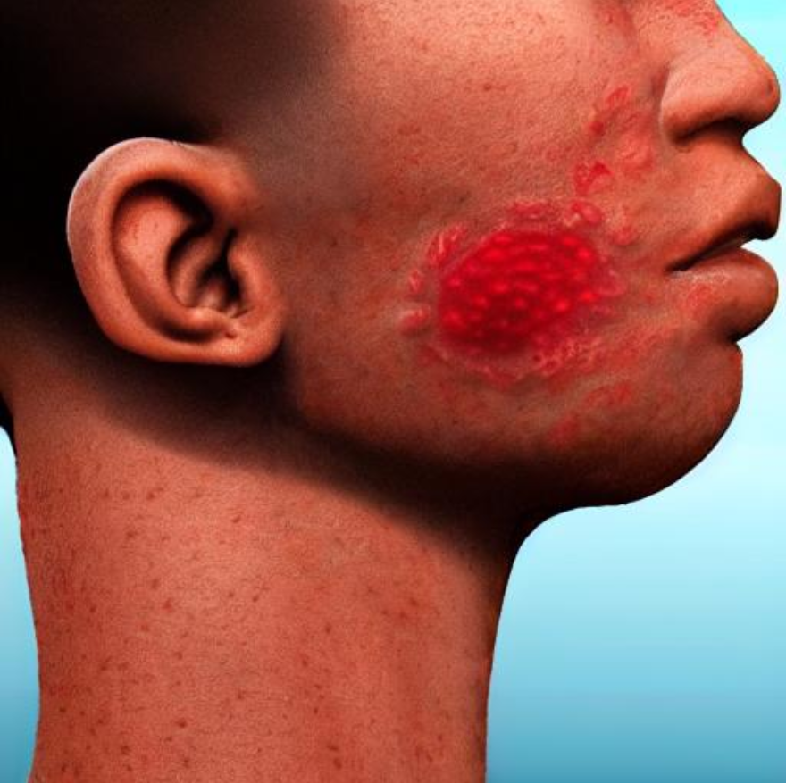

A detailed image showcasing the neck of a person with medium brown skin. The neck has a typical ringworm infection, identified by a round red rash with a slightly raised, scaly edge and smoother skin in the middle. The emphasis is on the neck and the exact portrayal of the ringworm infection.

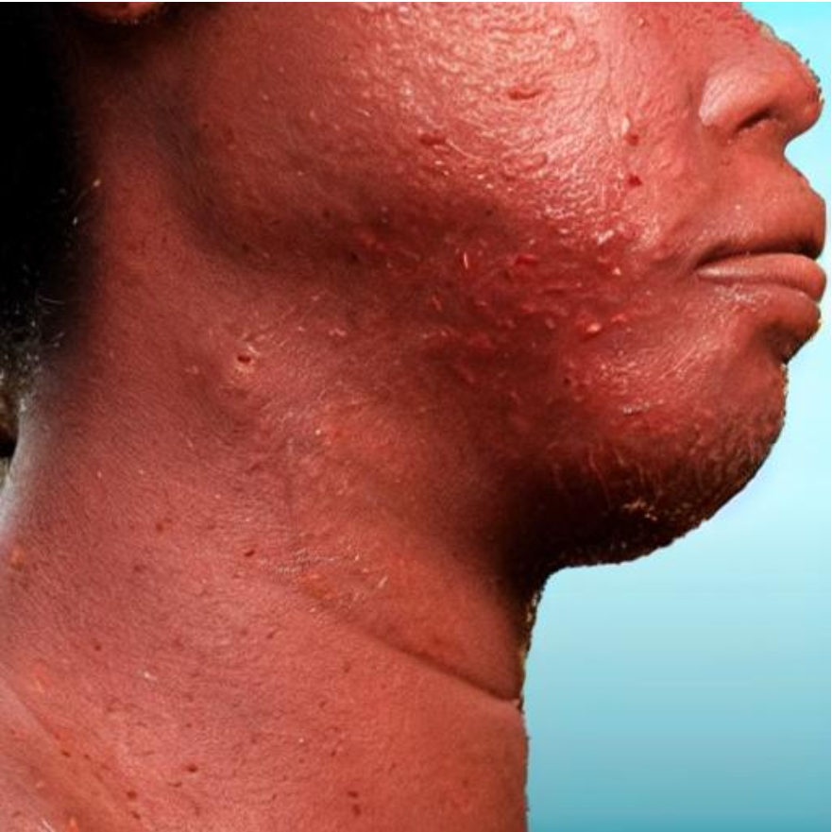

Create a highly detailed image showing the neck of a person with light brown skin. The neck reveals a ringworm infection, defined by a clear, circular red rash with a scaly border and healthy-looking skin at the center. The focus remains on the neck and the precise depiction of the skin condition.

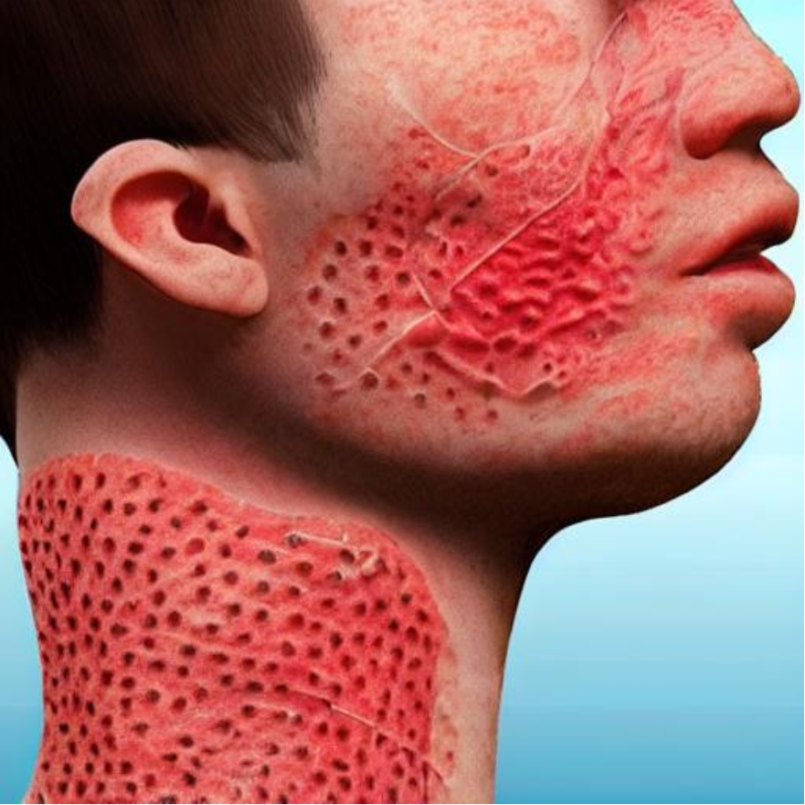

An image showing a realistic portrayal of the neck of a person with light brown skin. The neck displays a classic ringworm infection, characterized by a red, circular rash with a slightly raised, scaly border and clearer skin within the circle. The emphasis remains on the detailed depiction of the ringworm infection on the neck.

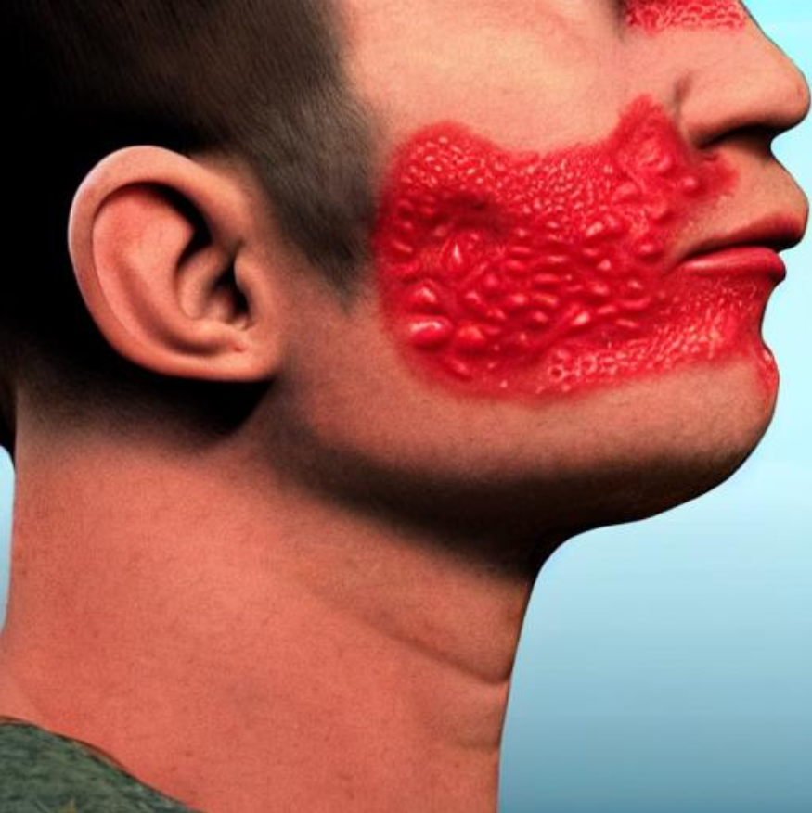

A detailed image focusing on the neck of a person with dark brown skin. The neck shows a typical ringworm infection with a distinct circular red rash and a slightly elevated, scaly edge, with the center appearing healthier. The emphasis remains on the accurate depiction of the ringworm infection on the neck.

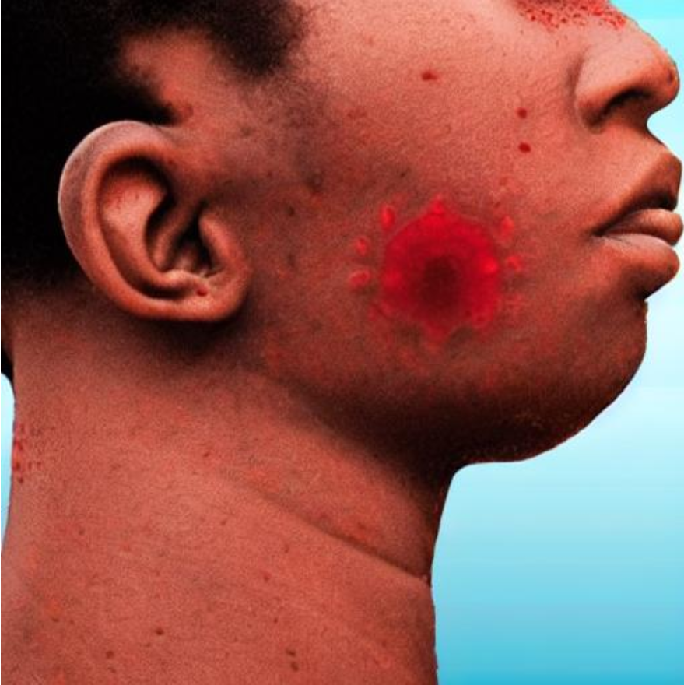

A highly detailed image depicting the neck of a person with medium brown skin. The neck has a clear ringworm infection, featuring a visible circular red rash with a raised, scaly border and healthier skin in the center. The emphasis remains on the detailed depiction of the ringworm condition on the neck.

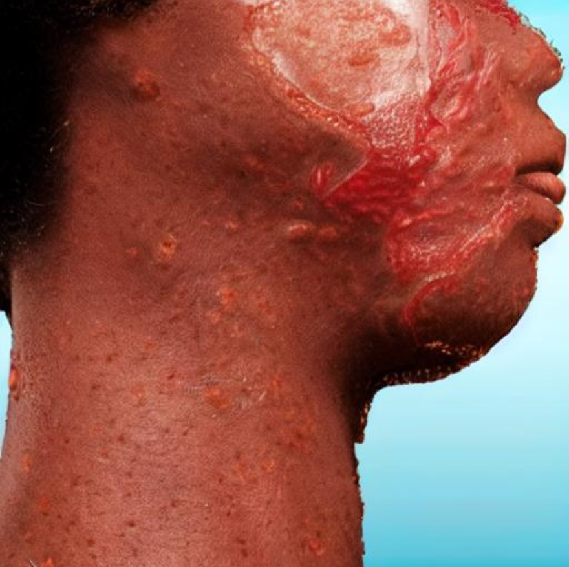

Create a detailed image showing the neck of a person with light brown skin. The neck displays a typical ringworm infection, characterized by a round red rash with a slightly raised, scaly edge and clearer skin in the center. The focus remains on the neck and the detailed portrayal of the ringworm condition. Other part of the body is healthy and not affected.

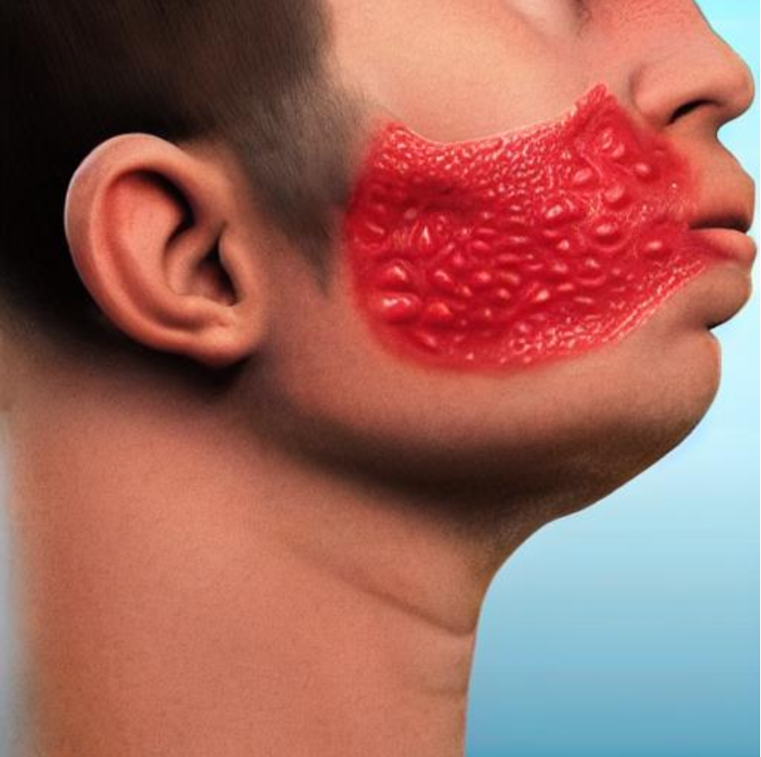

An image showing a realistic depiction of the neck of a person with medium brown skin. The neck shows a typical ringworm infection with a circular red rash, featuring a raised, scaly border and smoother skin. The emphasis is on the detailed depiction of the ringworm condition on the neck.

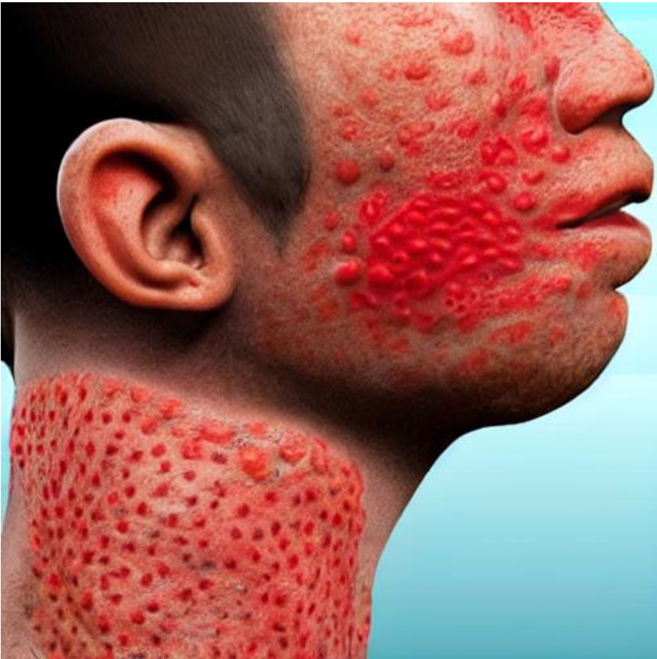

A highly detailed image depicting the neck of a person with dark brown skin. The neck has a typical ringworm infection, with a clear, circular red rash featuring a slightly raised, scaly edge and a smoother center. The emphasis remains on the accurate portrayal of the ringworm condition on the neck. The other part like face is healthy and looks normal.



Create a detailed image showing the neck of a person with light brown skin. The neck reveals a typical ringworm infection, characterized by a circular red rash with a slightly raised, scaly edge and healthier skin in the center. The focus is on the accurate depiction of the ringworm condition on the neck.

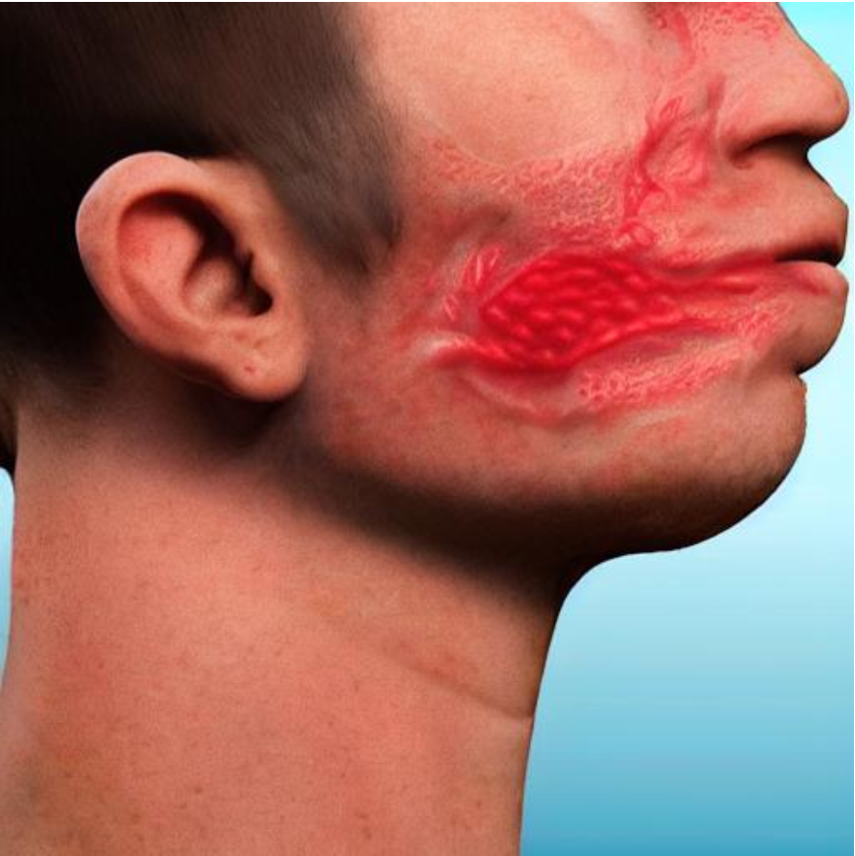

A highly detailed image showing the neck of a person with medium brown skin. The neck shows a ringworm infection, characterized by a circular red rash with a slightly raised, scaly border and smoother skin in the middle. The emphasis remains on the accurate depiction of the ringworm condition on the neck.

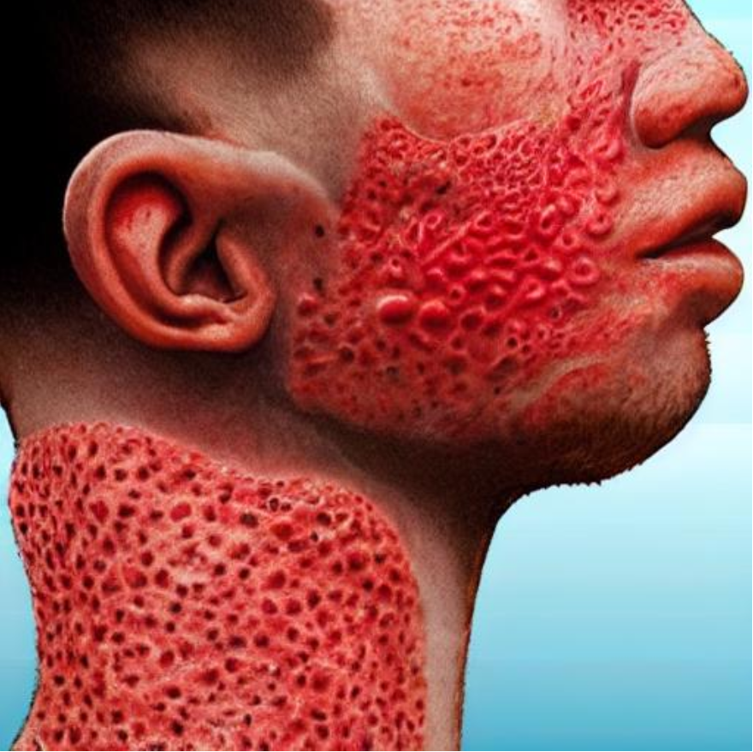

An image depicting the neck of a person with dark brown skin, showing a typical ringworm infection with a circular red rash and a slightly raised, scaly border. The focus is on the neck and the accurate portrayal of the ringworm condition.

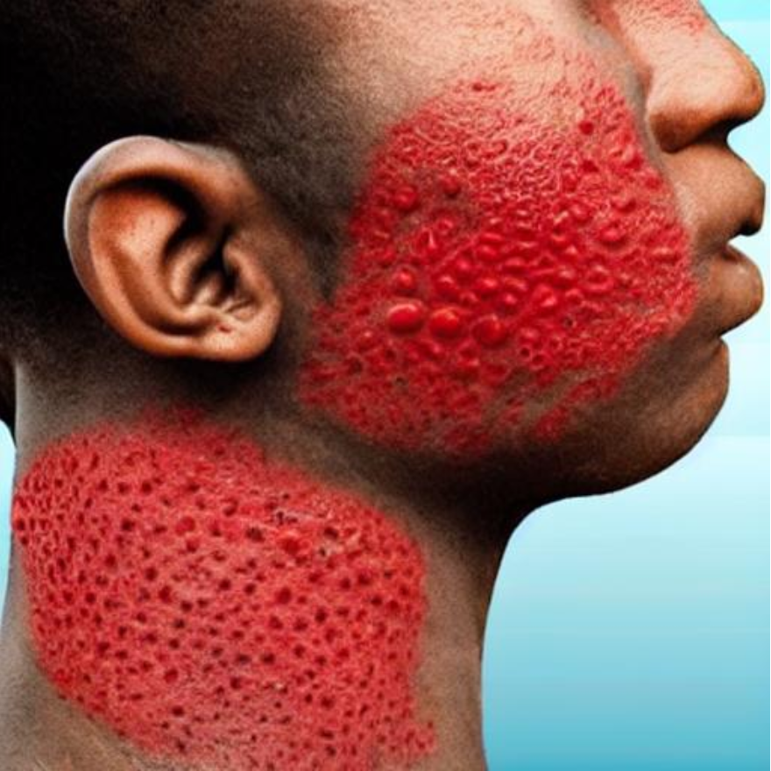

Create a realistic image showing the neck of a person with light brown skin. The neck displays a typical ringworm infection, characterized by a circular red rash with a raised, scaly edge and healthier-looking skin in the center. The emphasis remains on the accurate depiction of the ringworm condition on the neck.

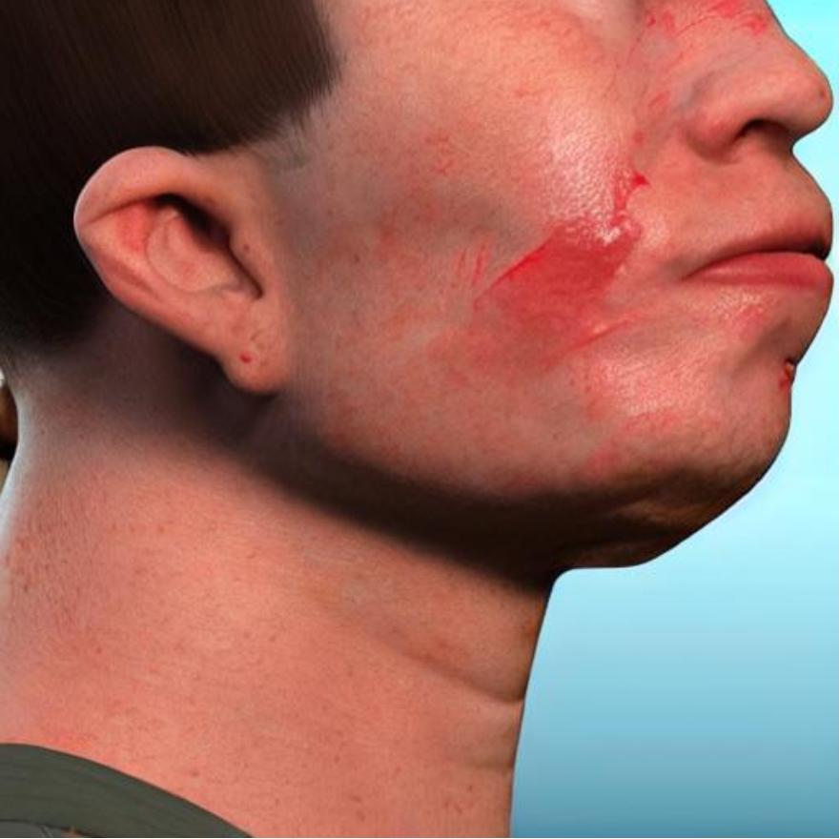

An image showing a detailed depiction of the neck of a person with dark brown skin. The neck displays a classic ringworm infection with a round red rash, featuring a slightly raised, scaly border and smoother skin in the center. The focus remains on the detailed portrayal of the ringworm condition on the neck.

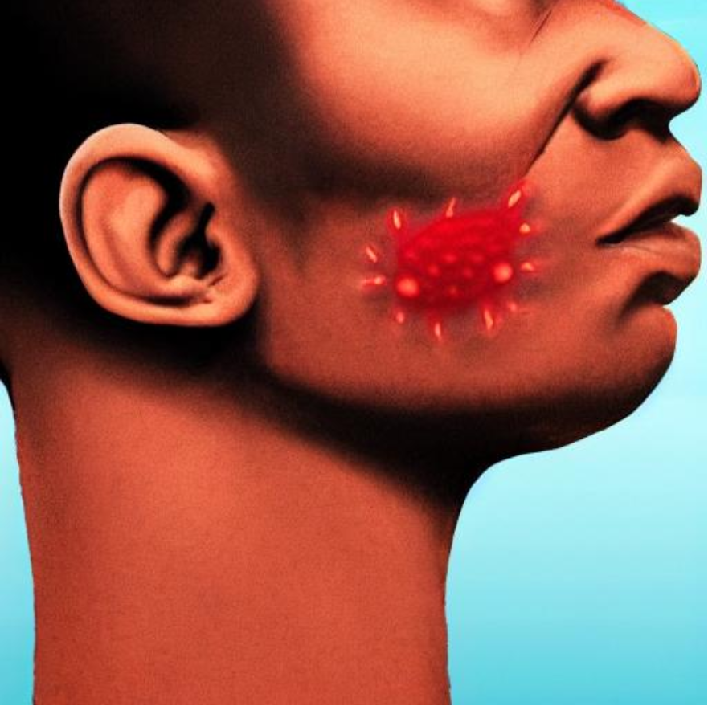

A highly detailed image depicting the neck of a person with medium brown skin. The neck shows a clear ringworm infection, characterized by a circular red rash with a raised, scaly edge and healthier skin within the circle. The emphasis remains on the accurate depiction of the ringworm condition on the neck.

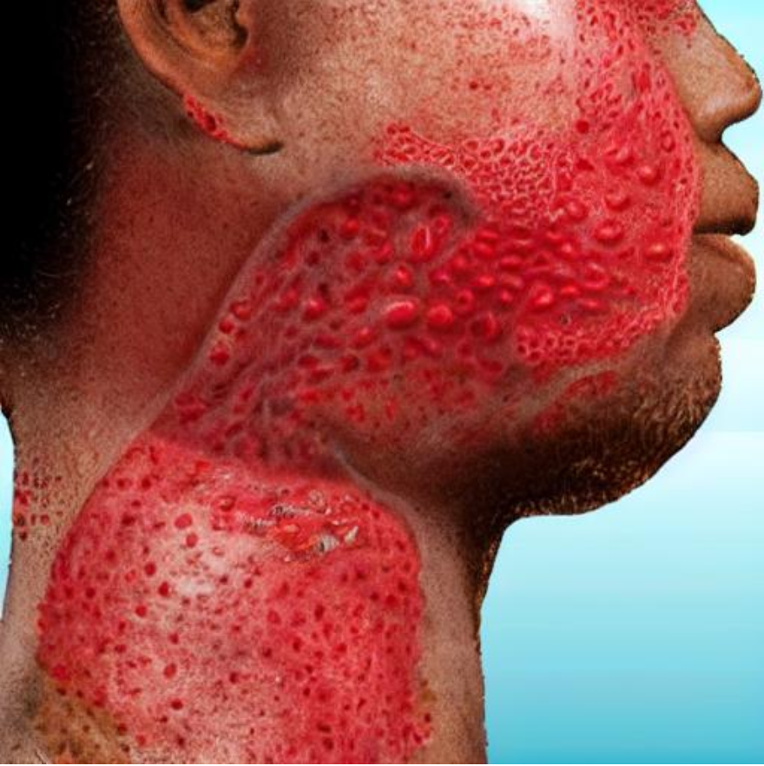

Create a realistic image showing the neck of a person with dark brown skin. The neck has a ringworm infection with a distinct circular red rash and a raised, scaly edge, with the center appearing healthier. The focus is on the detailed depiction of the ringworm condition on the neck.

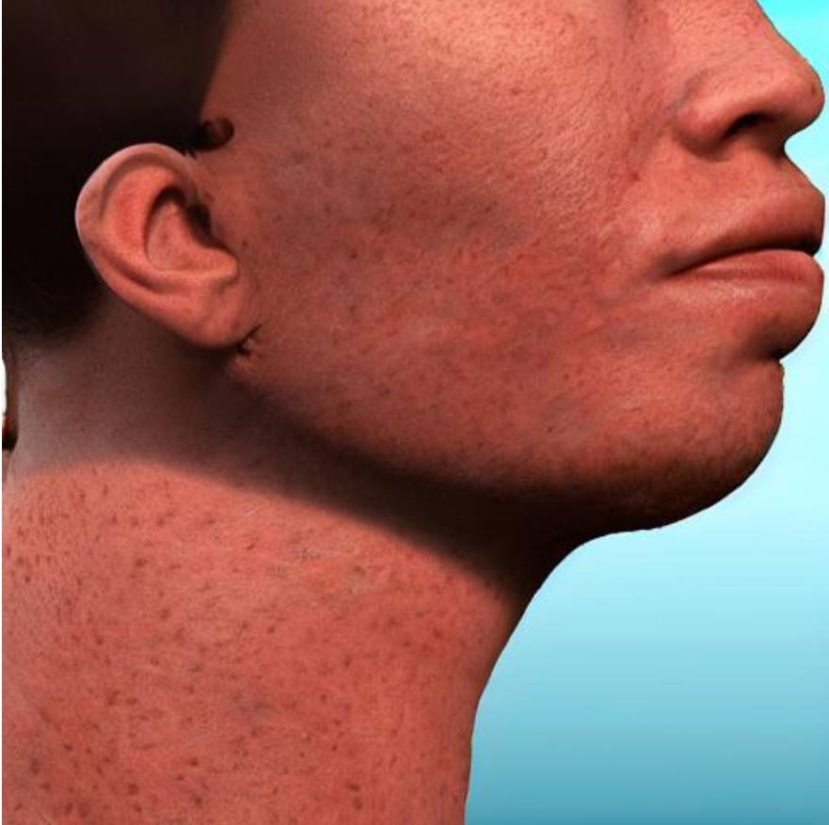

An image showing a highly detailed depiction of the neck of a person with light brown skin. The neck displays a typical ringworm infection, characterized by a circular red rash with a slightly raised, scaly edge and healthier-looking skin in the middle. The focus is on the accurate depiction of the ringworm condition on the neck.

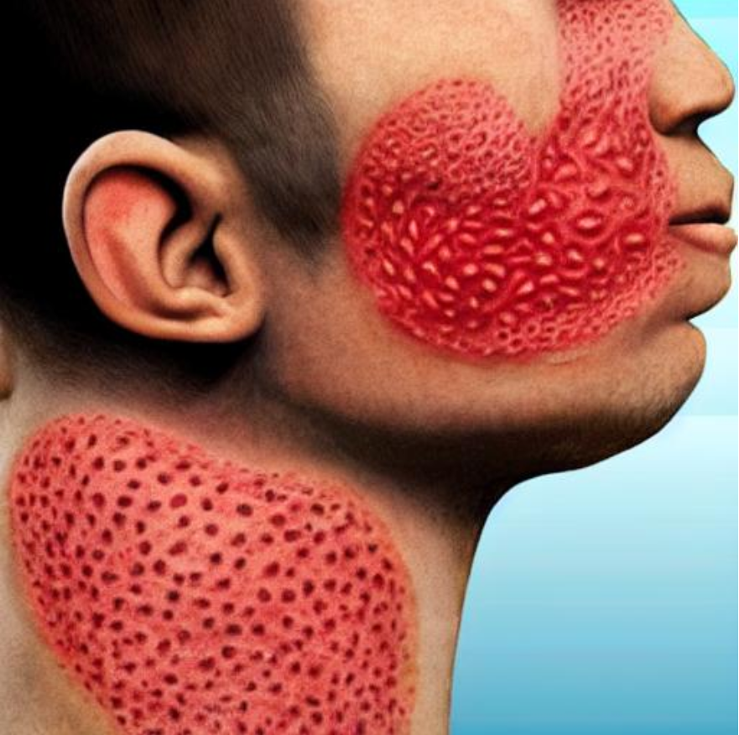

A detailed image showing the neck of a person with dark brown skin. The neck has a ringworm infection with a distinct circular red rash and a slightly elevated, scaly border. The focus remains on the accurate depiction of the ringworm condition on the neck.

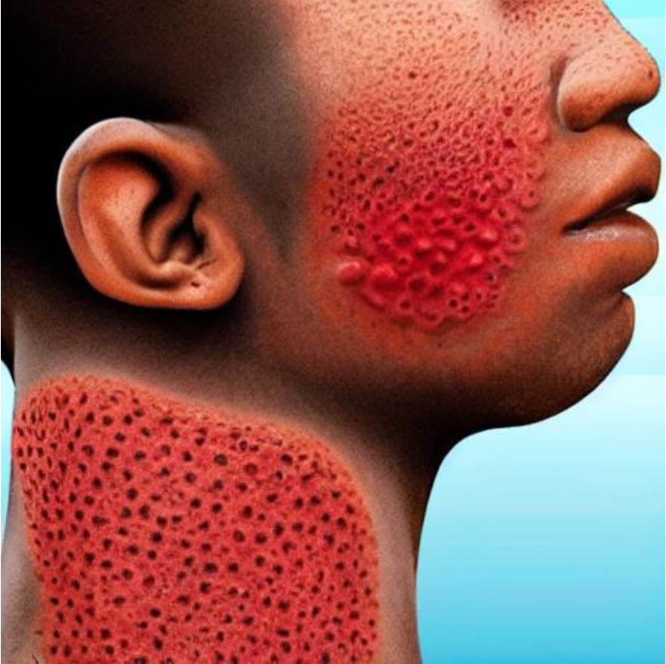

Create a detailed image showing the neck of a person with light brown skin. The neck displays a ringworm infection with a round red rash and a slightly raised, scaly edge, with a healthier-looking center. The emphasis remains on the detailed depiction of the ringworm condition on the neck.

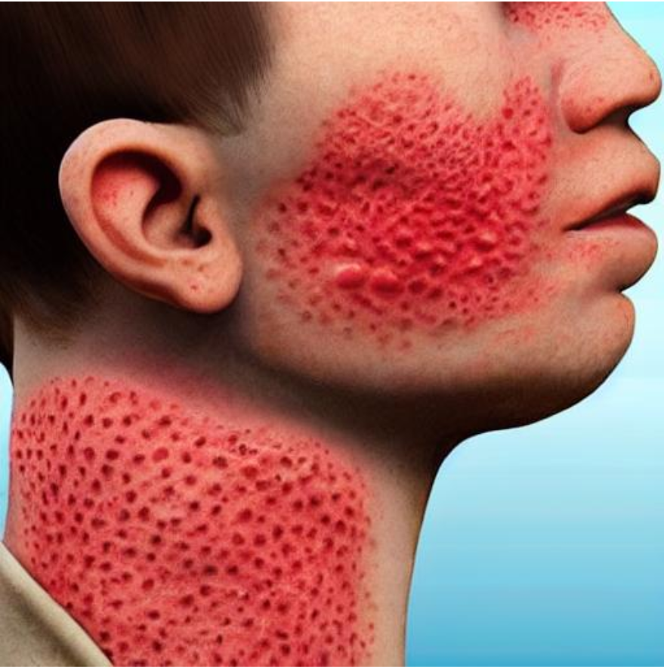

A highly detailed image showing the neck of a person with dark brown skin. The neck shows a typical ringworm infection with a circular red rash, featuring a slightly raised, scaly edge and clearer skin in the center. The emphasis remains on the accurate depiction of the ringworm condition on the neck.

